2023 TRUSTEE NOMINATION FORM
THREE YEAR TERM

Name of candidate:______________________________________________________________
(Please print name in full)

Signature of candidate: ____________________________ Date: ___________________

Nominator full name, address and contact number:

(Please print name and details in full)

Signature of nominator:____________________________ Date: ___________________

Nominations can be returned to the attention of the Board Secretary by:

- Post: Te Rūnanga o Ngāti Rārua
PO Box 1026
Blenheim 7240

- In person: Te Whare Mānuka
187 Bridge Street
Nelson 7010
or
Tokomaru House
15 Kinross Street
Blenheim 7201

- Email BoardSecretary@ngatirarua.iwi.nz

Please Note:
- The candidate must reside inside the Ngāti Rārua Area of Interest (see below)
- Candidates and nominators must be Registered Members who are resident in New Zealand, aged 18 years or over.
- Nominations must be signed by both the candidate and nominator.
- Nominations may not be withdrawn once submitted.
- Please contact the Board Secretary with any questions about the process or eligibility.
- Trustees cannot be trust employees. An employee may be nominated for election as a Trustee but, if elected, must resign their position as an employee.
- Nominations must be received by the Trust Office no later than 4pm, Thursday 12 October 2023.

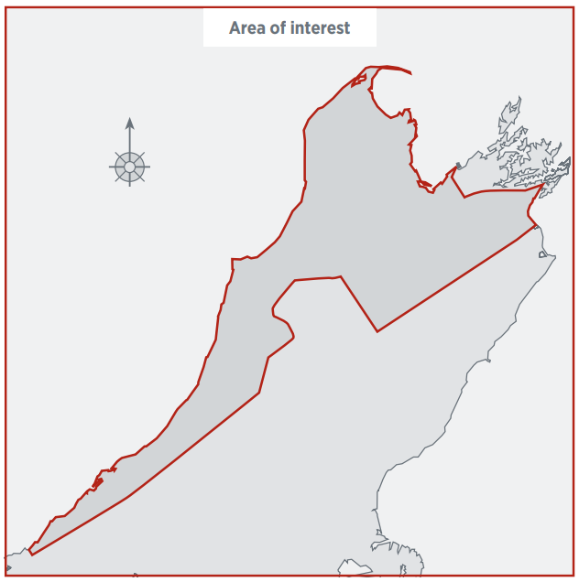

CANDIDATE TO COMPLETE

Please complete all sections of this form AND attach a statement and/or Curriculum Vitae (CV) containing details of experience and objectives relevant to the position of Trustee and a recent photograph/headshot.

Personal Details

Family Name: ___________________________________________________________

First Name(s): ___________________________________________________________

Maiden Name: ___________________________________________________________

Known as: ___________________________________________________________

Address: _______________________________________________________________

I am a registered member of Ngāti Rārua Settlement/Iwi Trust Yes No

Contact numbers and email:

Home: ________________ Work: ________________ Tick if you may be contacted at work

Mobile: _________________ Email address: ______________________________

I reside in the Ngāti Rārua area of interest Yes No

Please state where you reside________________________________________

Criminal Convictions
Have you been convicted of any offence against the law within the last 10 years or do you have any criminal charges pending? Yes No
If YES, please provide full details:

_____________________________________________________________________
_____________________________________________________________________
_____________________________________________________________________

_____________________________________________________________________
Declaration

I certify that the information provided is correct and no relevant material / information has been omitted.

I agree to the disclosure of all criminal convictions by the New Zealand Police to Ngāti Rārua Iwi Trust / Ngāti Rārua Settlement Trust.

I declare that I am not a person who is precluded from holding office as a Trustee because of one or other of the matters specified in clause 4.5 of the Deed of Trust of Ngāti Rārua Iwi Trust and clause 4.6-4.9 of the Deed of Trust of Ngāti Rārua Settlement Trust as outlined below.

Clause 4.5, Deed of Trust – Ngāti Rārua Iwi Trust

4.5 Any person shall cease to be a Trustee if he or she:

shall have been in office for more than three years since his or her election; or

resigns as a Trustee by giving notice in writing to the Trust; or
- fails or neglects to attend three consecutive meetings of the Trustees without leave or absence, unless it appears to the other Trustees at their first meeting after the last of such absences that there is a proper reason for such non-attendance; or

becomes of unsound mind, becomes a person in respect of whose affairs an order under the Protection of Personal and Property Rights Act 1988 is made, or otherwise becomes unfit or unable to act as a Trustee; or

an act of bankruptcy or is an undischarged bankrupt; or

is or has ever been convicted of a crime or offence involving dishonesty as defined in section 2 (1) of the Crimes Act 1961, or an offence under section 373(4) of the Companies Act 1993; or
- dies or, if elected as one of the resident trustees in terms of clause 4.1, no longer meets the residence requirements in that clause.

Clause 4.6-4.9, Deed of Trust – Ngāti Rārua Settlement Trust

4.6 A person is ineligible to be a Trustee if the person:

- Is bankrupt and/or has within the last five (5) years been adjudged bankrupt;
- Is or has ever been convicted of an offence involving dishonesty as defined in section 2 (1) of the Crimes Act 1961, or an offence under section 373(4) of the Companies Act 1993 (unless that person is an eligible individual for the purposes of the Criminal Records (Clean Slate) Act 2004);
- Is or has ever been disqualified from being a Director of a company registered under the Companies Act 1955 or the Companies Act 1993;
- Is or has ever been removed as a Trustee of a trust by order of a Court on the grounds on breach of trust, lack of competence or failure to carry out the duties of a Trustee satisfactorily;
- Becomes subject to a compulsory treatment order under the Mental Health (Compulsory Assessment and Treatment) Act 1992;
- Becomes subject to a property order made under section 30 or section 31 of the Protection of Personal and Property Rights Act 1988;
- Refuses to act when they are required to act;
- Is absent without leave for three (3) consecutive meetings; and/or
- Is or has ever been convicted of an indictable offence.

…

4.8 An employee of the Trust may be nominated for election as a Trustee but, if elected, must forthwith resign his or her position as an employee as the case may be.

4.9 A person shall cease to be a Trustee if the Trustee:

- Resigns or retires by giving written notice to the Secretary;
- Dies;
- Ceases to be eligible to be a Trustee under Clause 4.6; or
- Is the subject of a Special Resolution at a Special General Meeting removing him or her as a Trustee.

Signed: __________________________________ Date: ____/____/____
(Candidate signature)

CHECKLIST

Please check that the following has been completed on all forms:

written signatures of both the candidate and the nominator
(Nominations may not be withdrawn after they have been received by the Trust Office);

a declaration signed by the candidate that declares that the candidate is not a person who is precluded from holding office as a Trustee on the basis of one or other of the matters specified in clause 4.5 of the Deed of Trust of Ngāti Rārua Iwi Trust and/or 4.6 of the Deed of Trust of Ngāti Rārua Settlement Trust; and

a brief statement or CV containing details of experience and objectives relevant to the position of Trustee.

a recent photograph, passport or portrait type

Nominations of candidates must be received by the Trust Office no later than 4pm, Thursday 12 October 2023.

For Office Use Only:

Confirmation of Eligibility Candidate Y/N Date Nomination Form Received:
Nominator Y/N

